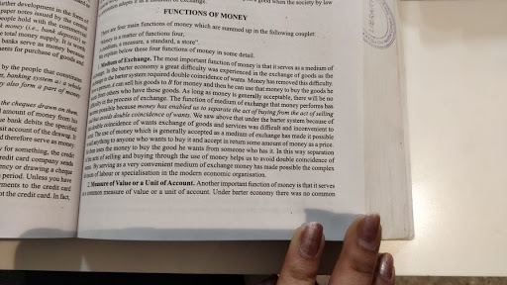 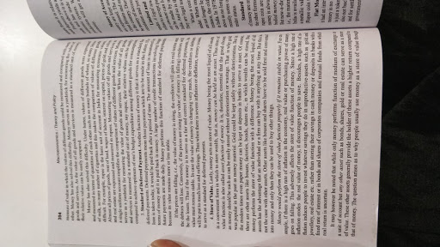 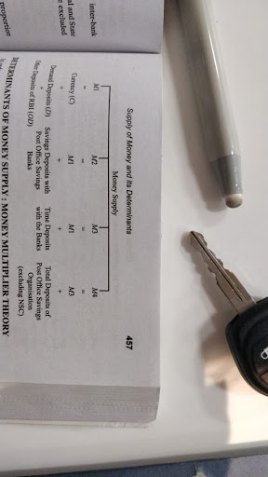

**MODULE 5 DEMAND AND SUPPLY OF MONEY (VERY EASY MODULE)**

DEFINITION OF MONEY: PROFESSOR D H ROBERTSON DEFINES MONEY AS "ANYTHING WHICH IS WIDELY ACCEPTED IN THE PAYMENT OF GOODS OR IN DISCHARGE OF OTHER KINDS OF BUSINESS OBLIGATION"

ACCORDING TO CROWTHER"MONEY CAN BE DEFINED AS ANYTHING THAT IS GENUINELY ACCEPTABLE AS MEANS OF EXCHANGE AND THAT AT SAME TIME ACTS AS A MEASURE AND A STORE OF VALUE" (IMP)

2 IMP THINGS ABOUT MONEY EMERGE FROM ABOVE DEFINITION

1. MONEY HAS BEEN DEFINED IN TERMS OF FUNCTIONS IT PERFORMS

2. AN ESSENTIAL REQUIREMENT OF ANY KIND OF MONEY IS THAT IT MUST BE GENERALLY ACCEPTABLE TO EVERY MEMBER OF SOCIETY

                                                     FUNCTIONS OF MONEY

ANS: REFER TO THE GROUP

                                                      SUPPLY OF MONEY

BY MONEY SUPPLY WE MEAN THE TOTAL STOCK OF MONETARY MEDIA OF EXCHANGE AVAILABLE TO A SOCIETY FOR USE IN THE CONNECTION WITH THE ECONOMIC ACTIVITY IN THE COUNTRY. ACCORDING TO THE STANDARD CONCEPT OF MONEY SUPPLY IT IS COMPOSED OF FOLLOWING TWO ELEMENTS

1. CURRENCY WITH THE PUBLIC :

2. DEMAND DEPOSIT WITH THE PUBLIC :

TWO THINGS MUST BE NOTED WITH REGARD TO REGARD TO MONEY SUPPLY IN THE ECONOMY

1. THE MONEY SUPPLY REFERS TO THE TOTAL SUM OF MONEY AVAILABLE TO THE PUBLIC IN THE ECONOMY AT A POINT OF TIME ,i.e, MONEY SUPPLY IS THE STOCK CONCEPT IN SHARP CONTRAST TO THE NATIONAL INCOME WHICH IS A FLOW CONCEPT

2. MONEY SUPPLY ALWAYS REFERS TO THE AMOUNT OF MONEY HELD BY THE PUBLIC. THE TERM PUBLIC INCLUDES HOUSEHOLDS, FIRMS, INSTITUTIONS OTHER THAN BANK AND GOVERNMENT

                                                  MEASURES OF MONEY SUPPLY

1. MONEY SUPPLY(M1) OR NARROW MONEY : THIS IS THE NARROW MEASURE OF MONEY SUPPLY AND IS COMPOSED OF FOLLOWING ITEMS :

                                                   M1 = C + DD + OD

C = CURRENCY WITH PUBLIC

DD = DEMAND DEPOSIT WITH THE PUBLIC IN COMMERCIAL AND COOPERATIVE BANKS

OD = OTHER DEPOSITS HELD BY PUBLIC WITH RBI

C CONSIST OF FOLLOWING

 I. NOTES IN THE CIRCULATION

II. CIRCULATION OF RUPEE COIN AND SMALL COIM

III. CASH RESERVE ON HANDS WITH ALL BANKS\\

IN MEASURING DD WITH PUBLIC IN BANKS, INTER BANKS DEPOSITS .i.e, DEPOSITS HELD BY A BANK IN OTHER BANKS ARE EXCLUDED FROM THESE MEASURE

OTHER DEPOSITS WITH RBI INCLUDE

I. DEPOSITS WITH INSTITUTIONS LIKE UPI, IDBI, IFCI, NABARD ETC.

II. DEMAND DEPOSITS OF FOREIGN CENTRAL BANKS AND FOREIGN GOVT

III. DEMAND DEPOSITS FROM IMF AND WORLD BANK

2. MONEY SUPPLY(M2)

                               M2 = M1 + SAVING DEPOSIT WITH POST OFFICE SAVING BANKS

THE REASON WHY MONEY SUPPLY M2 HAS BEEN DISTINGUISHED FROM M1 IS THAT SAVING DEPOSITS WITH POST OFFICE SAVING BANKS ARE NOT AS LIQUID AS DEMAND DEPOSIT WITH COMMERCIAL AND COOPERATIVE BANKS AS THEY ARE NOT CHEQUABLE ACCOUNTS

3. MONEY SUPPLY (M3) OR BROAD MONEY

     M3 IS A BROAD CONCEPT OF MONEY SUPPLY

    M3 = M1 + TIME DEPOSITS WITH BANKS (FD)

IT IS GENERALLY THOUGHT THAT TIME DEPOSITS SERVE AS STORE OF VALUE AND REPRESENTS SAVING OF THE PEOPLE AND ARE NOT LIQUID AS THEY CANNOT BE WITHDRAWN THROUGH DRAWING CHEQUE ON THEM . HOWEVER SINCE LOANS FROM BANKS CAN BE EASILY OBTAINED AGAINST THIS TIME DEPOSITS , THEY CAN BE USED IF FOUND NECESSARY FOR TRANSACTION PURPOSES . FURTHER THEY CAN E WITHDRAWN AT ANY TIME BY FORGOING SOME INTEREST EARNED ON THEM

4. MONEY SUPPLY (M4)

  M4 = M3 + TOTAL DEPOSITS WITH POST OFFICE SAVINGS ORGANISATION